**Module 3 Lab 2: Integrating MongoDB with Express.js**

Mohiddeen Vilak Mohammad

Department of Information Technology, Arizona State University

IFT 554: Middleware Programming & Database Security

Dinesh Sthapit

February 18, 2024

**Figure 1:**

*Manually adding config.env file*

**Figure 2:**

**Figure 3:**

*MongoDBCrud.js file*

**Figure 4:**

**Figure 5:**

*testCRUD.js file*

**Figure 6:**

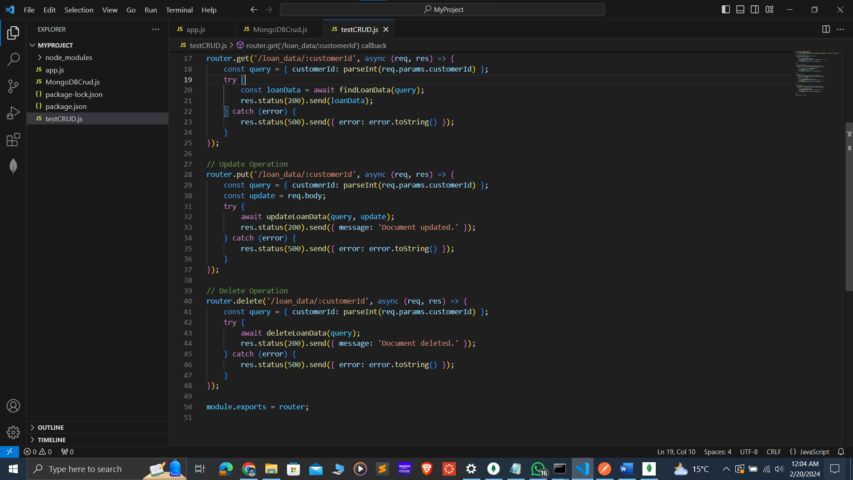

**Figure 7:**

*Post request using postman*

**Figure 8:**

*Gett request using postman*

**Figure 9:**

*Put request using postman*

**Figure 10:**

*Delete request using postman*

**Figure 11:**

*Database after all the operations*

